A Recipe For:

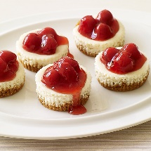 

# Cherry Cheesecakes

**From the Kitchen of:** Mom

**Servings:** 12

**Prep Time:** 20 min **Bake Time:** 15 Min. **Bake Temp:** 375

**Ingredients:**

* ¾ cup graham cracker crumbs
* 2 Tbsp light butter, melted
* 2/3 cup low-fat cream cheese
* 6 Tbsp fat-free cream cheese
* 3 Tbsp fresh lemon juice
* 2 large egg whites
* 1 ½ tsp vanilla
* ½ cup sugar
* ¾ cup light cherry pie filling

1. Place 12 cupcake liners in a cupcake pan. Preheat oven to 375.
2. In a small bowl, combine graham cracker crumbs and butter: mix well. Spoon 1 Tbsp of crumb mixture into bottom of each line and press down gently: Refrigerate until ready to use.
3. In a medium bowl, using an electric mixer, beat both types of cream cheese together until fluffy. Add lemon juice, egg whites, vanilla and sugar; beat until smooth.
4. Spoon cream cheese mixture evenly into muffin liners; bake until set, about 15 minutes. Remove from oven and allow to cool.
5. Top each cheesecake with 1 Tbsp cherry pie filling.

NOTE: If you can’t find both kinds of cream cheese, use all the same kind.